ALGORITHMS LABORATORY

[CS39001]
Individual Work
Lab. No.- 3 Date. : 11.08.2025
Roll Number: | 2328159 | Branch/Section: | CSSE-1
Name in Capital: | AYUSH RAJ

Program No: 3.1

Program Title:
Write a program using a user-defined function to calculate the factorial of a given number
n, where n is taken as input from the user. Before implementing the program, analyze the
time complexity of the factorial function using the step count method for at least five
different values of n on paper. After completing the analysis, modify the factorial
function by introducing a count variable to track the number of computational steps
during execution, as discussed in class. This will help in validating the theoretical step
count with the actual implementation.
Input/Output Screenshots:
RUN-1:

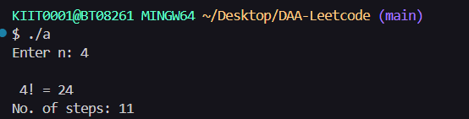

RUN-2

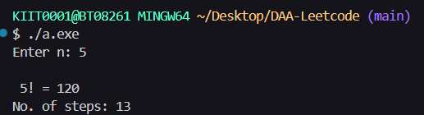

Source code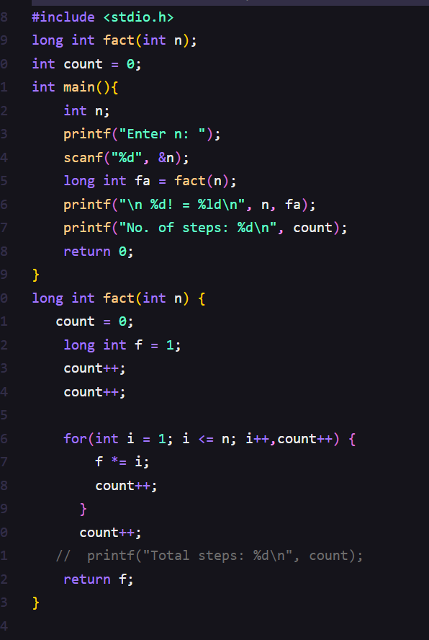

Conclusion/Observation
The program successfully calculates the factorial of a number and counts the computational steps, validating the time complexity analysis

Program No: 3.2

Program Title:
Write a menu (given as follows) driven program to sort a given set of elements using the
Insertion sort method and determine the time required to sort the elements. Repeat the
experiment for different values of n, the number of elements in the list to be sorted and
plot a graph of the time taken versus n. The elements can be read from a file or can be
generated using the random number generator.
INSERTION SORT MENU
0. Quit
1. n Random numbers=>Array
2. Display the Array
3. Sort the Array in Ascending Order
4. Sort the Array in Descending Order
5. Best Case Time Complexity
6. Worst Case Time Complexity
7. Average Case Time Complexity
8. Time Complexity all Cases (Best,
Worst & Average) in Tabular form for
values n=5000 to 50000, step=5000
Enter your choice:
If the choice is option 8, then it will display the tabular form as follows:

Input/Output Screenshots:
RUN-1:

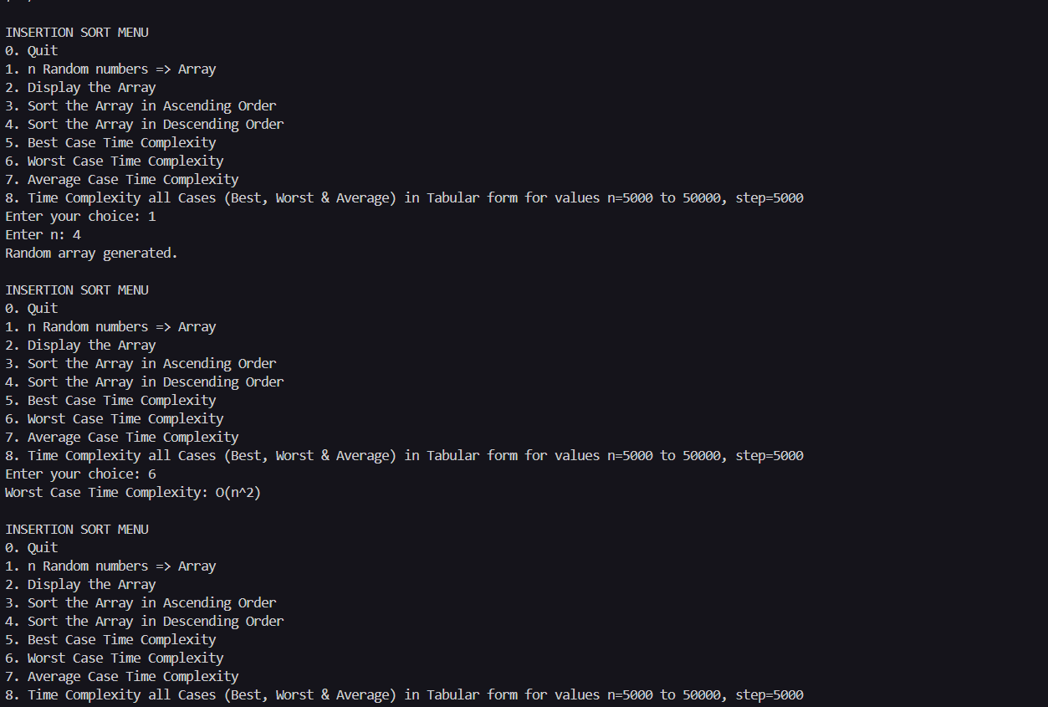

Source code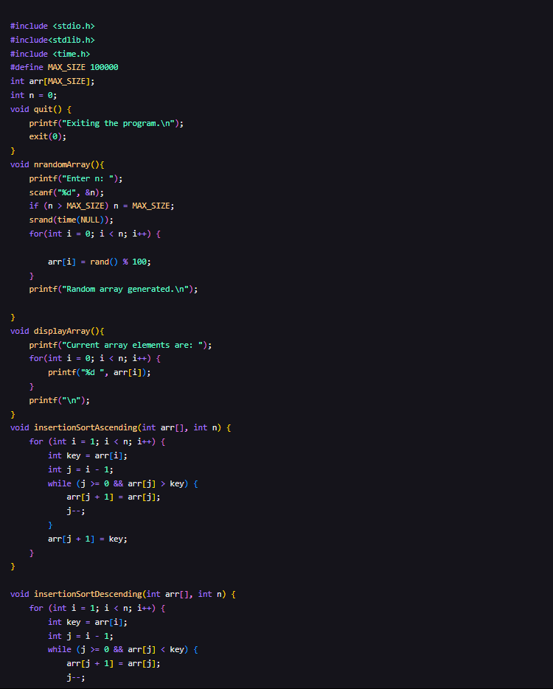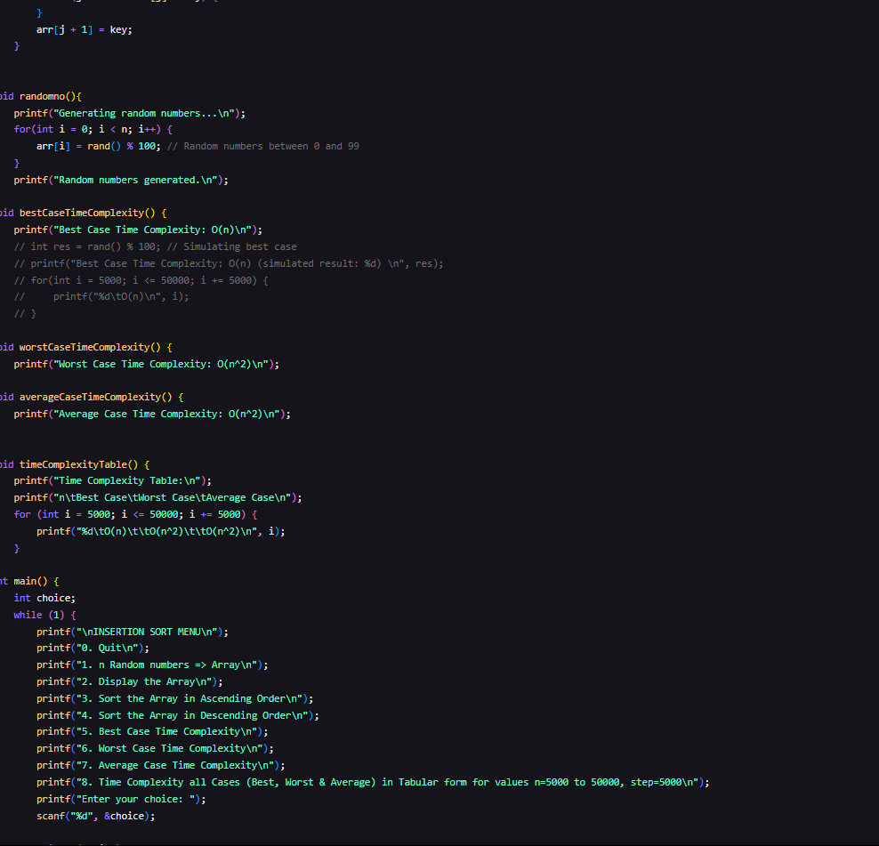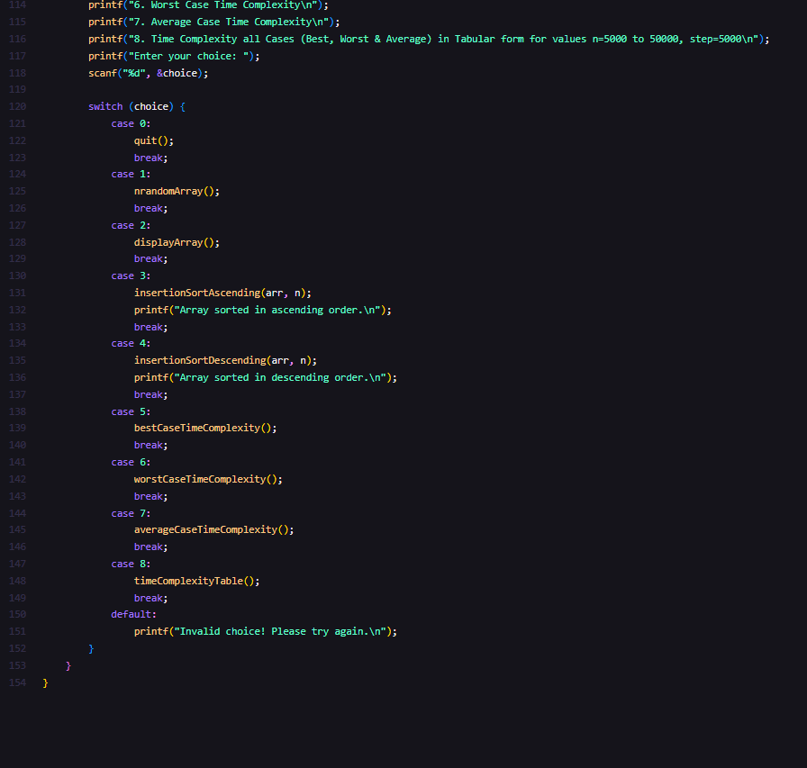

Conclusion/Observation
This program demonstrates insertion sort, allows performance analysis for different cases, and helps visualize time complexity trends for varying input sizes

